Newsletter article for circulation to stakeholder networks

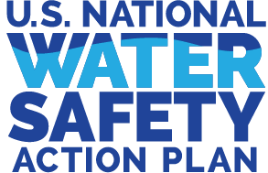

Creating a Water Safety Plan for the U.S. is a big task. We are ready for the challenge.

The World Health Organization recommends that all countries create a Water Safety Plan which addresses the nation’s drowning problem. To date, the United States has not had such a plan, but that is about to change. With the support of Water Safety USA, a Steering Committee has been formed to guide the development of just such a plan. For Stage 1, a framework and approach have been developed. Stage 2 of the plan development is now underway.

We believe that capturing the knowledge and experience of water safety professionals across the United States is essential in creating a water safety plan which is comprehensive, realistic, and executable. Stage 2 will involve working groups undertaking that work in six areas of focus: data surveillance, supervision/lifeguards, water safety/water competency/swimming lessons, rescue/CPR, fencing/barriers and life jackets. The end goal of their work will be to make recommendations for what a model “Water Safety State”, “Water Safety County” and “Water Safety Community” should look like, as well as identifying where national level work on minimum standards and guidelines will help support states, counties and communities in adopting and implementing the recommended evidence-based strategies.

You can help by contributing to Stage 2 of the process by putting your name forward as a key informant or reviewer, or you can help promote the development process to ensure we reach and include the input of water safety professionals at all levels across the country. We are also still looking for funders to help underwrite the cost of developing the plan.
We invite you to visit the website at https://www.watersafetyusa.org/nwsap.html for more information and to indicate your interest.

