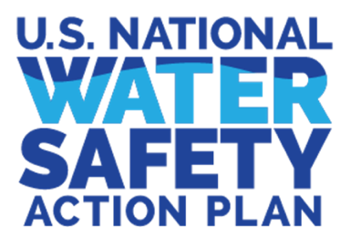

USNWSAP Social Media Posts

Greetings! We are excited that you are considering promoting the USNWSAP on your organization’s social media. Please do not begin to share the following posts until launch, June 29th, and consider these posts embargoed copies until then. On June 29th you can begin to post with the launch announcement and use the suggested timeline for the remaining posts to keep the water safety community engaged. Thanks again for collaborating with the USNWSAP to help prevent drowning nationwide.

- LAUNCHING TODAY— The U.S. National Water Safety Action Plan (@usnwsap) is the first-of-its-kind roadmap for taking collective action to reduce drownings in America.
Created by over 100 subject-matter experts and informed by evidence-based research and reviewed by nearly 400 community-level advocates across 48 states, the 10-year plan includes 99 action recommendations to address drowning at the federal, state, and local levels to reduce drownings nationwide.
Go to watersafetyplan.us to discover the #USNWSAP today.
[Insert your organization's name] is proud to support the #USNWSAP and contribute in a coordinated effort to help prevent drowning from sea to shining sea.
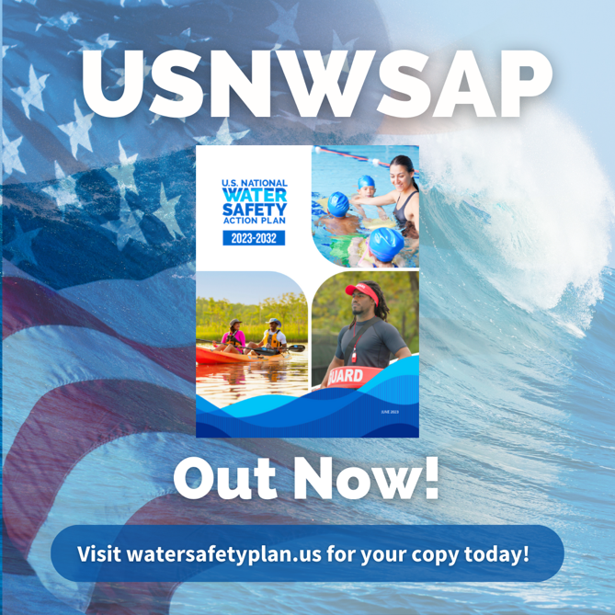

- The U.S. National Water Safety Action Plan (@usnwsap) is for anyone motivated to help keep people safe in on or around the water.

Across the country, thousands of individuals respond, educate, and advocate to help prevent drowning. If you know someone that plays a role in drowning prevention, or has a passion for water safety, tag them in the comments and let them know the #USNWSAP is for them! If you are newly interested in water safety and drowning prevention, the USNWSAP was created for you too!

[Insert your organization’s name] is proud to support the #USNWSAP. Together, through coordinated action, we can stop drownings.

Go to watersafetyplan.us to access the #USNWSAP and learn how you can collaborate to support water safety efforts.
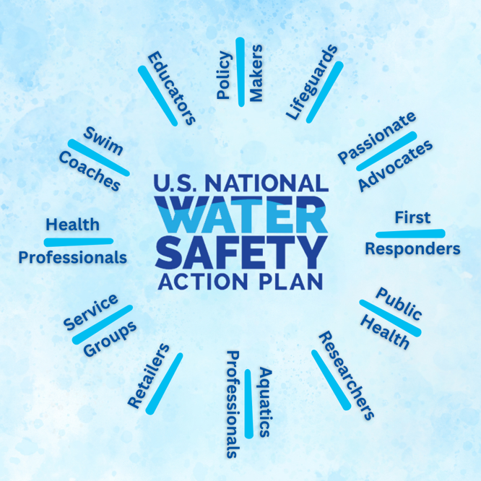

- The U.S. National Water Safety Action Plan (@usnwsap) is here to catalyze the development of context specific, data- and evidence-informed action plans to prevent drowning at the community, county and state levels. The Plan lays out both a core set of values and tools and resources to support that development.

How will you embody the USNWSAP? How will you respond to the call to action?

Visit watersafetyplan.us to learn more about the #USNWSAP call to action and share your responses today!
[Insert your organization's name] is proud to support the #USNWSAP and contribute in a coordinated effort to help prevent drowning nationwide.

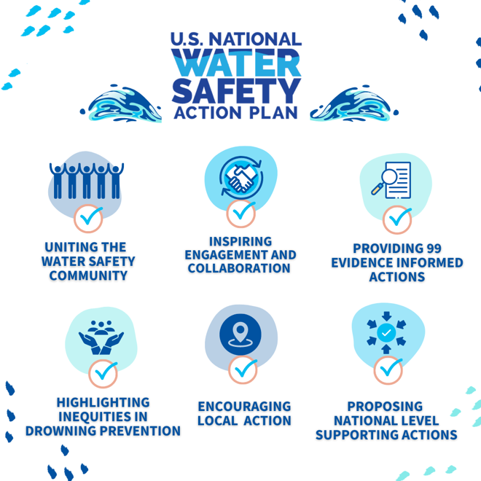

- The U.S. National Water Safety Action Plan (@usnwsap) lays out a vision for a country where everyone is safe in, on, and around the water.

While the USNWSAP provides the roadmap and guidance on drowning prevention efforts, the real change starts with you. How will you keep your community safe?

Share a video stating how you will help enact water safety in your community and share it to your story tagging @usnwsap.

Don’t know where to start? Explore the #USNWSAP at watersafetyplan.us to discover ways to promote water safety around you.
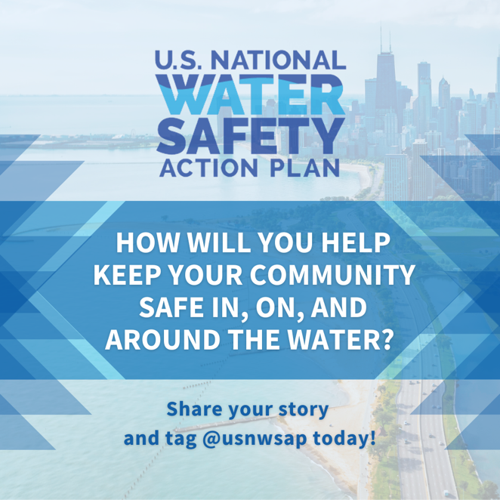
[Insert your organization's name] is proud to support the #USNWSAP and contribute in a coordinated effort to help prevent drowning nationwide.

- The U.S. National Water Safety Action Plan (@usnwsap) aims to unite the water safety community to collectively and more effectively prevent drowning.

The “U” in #USNWSAP is for United. Together we can stop drownings. The “U” is also for U (you)! “U” are the biggest part of the USNWSAP. Without “U” we can’t make positive change, and we need U to help save lives.

We encourage “U” to take a picture of yourself forming a “U” with your arms (see example in this post) in front of a place where you hope your local plan will take action to prevent drowning. Post and tag @usnwsap and tell us more about how you will use the #USNWSAP to help coordinate actions within your water safety community. Thank “U”!

Head to watersafetyplan.us to learn more about how the #USNWSAP can help “U” with your water safety efforts.
[Insert your organization's name] is proud to support the #USNWSAP and contribute in a coordinated effort to help prevent drowning nationwide.
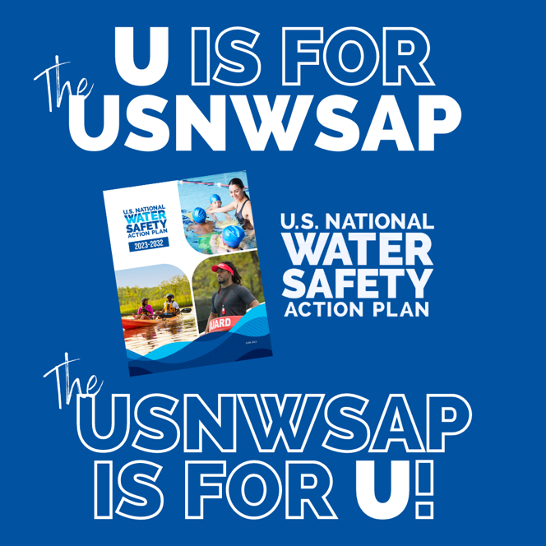
- Drowning can happen to anyone, anywhere there is water. Aquatic activities, such as swimming, boating, and paddle sports, however, can be an incredible benefit to those who participate. The U.S. National Water Safety Action Plan (@usnwsap) calls on communities, counties, and states to develop data- and evidence-informed context specific action plans to reduce hazards and help people enjoy the benefits of the water safely.

Visit watersafetyplan.us for more information about the #USNWSAP to learn more about the call to action.
[Insert your organization's name] is proud to support the #USNWSAP and contribute in a coordinated effort to help prevent drowning nationwide.
